SEQUENCE DIAGRAMS:

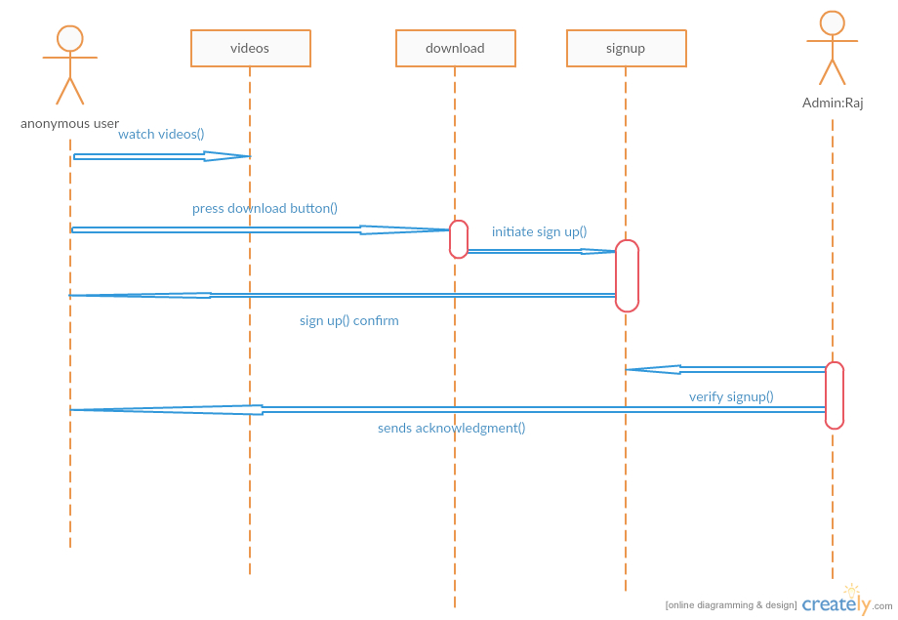

* In the above sequence diagram of downloading a video (or) audio if anonymous user enter in to our system.
* Anonymous user: He or she is not our user until he signed up for our system. But the anonymous user can watch or listen our videos and audios.
* If anonymous user press the download button it will send him to the sign up page and if he completed the signup page the admin verifies his account and activates his account.

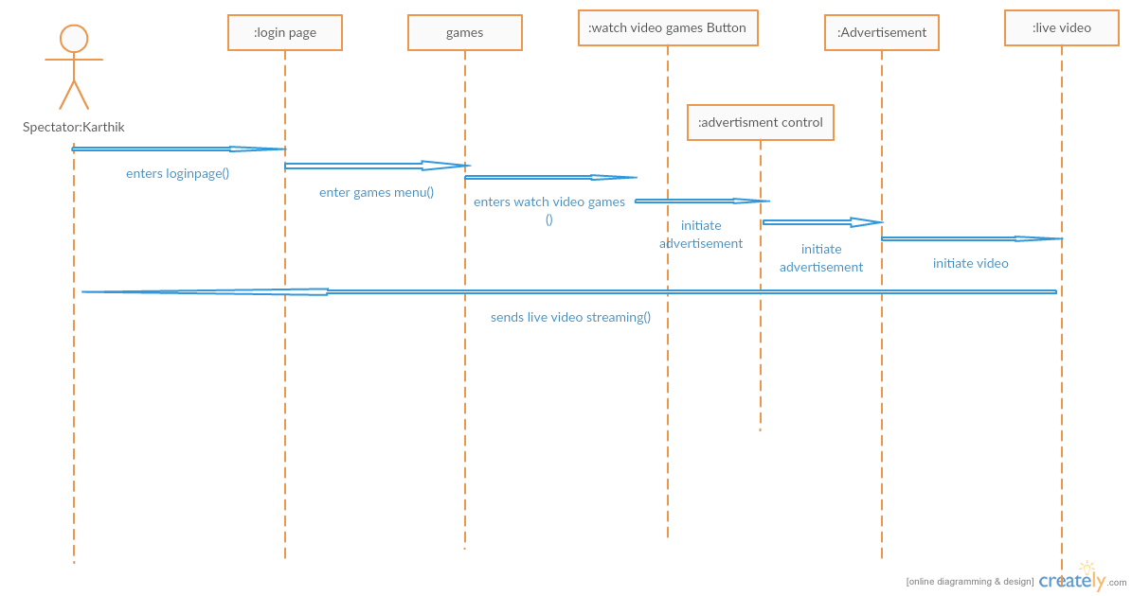

* In the above diagram spectator who becomes our user but acts as a spectator who wants to see video game. Who logins to his page and enters into game menu and press the watch video games button which was taken by advertisement control object which will initiates the advertisement and initiates the live video.

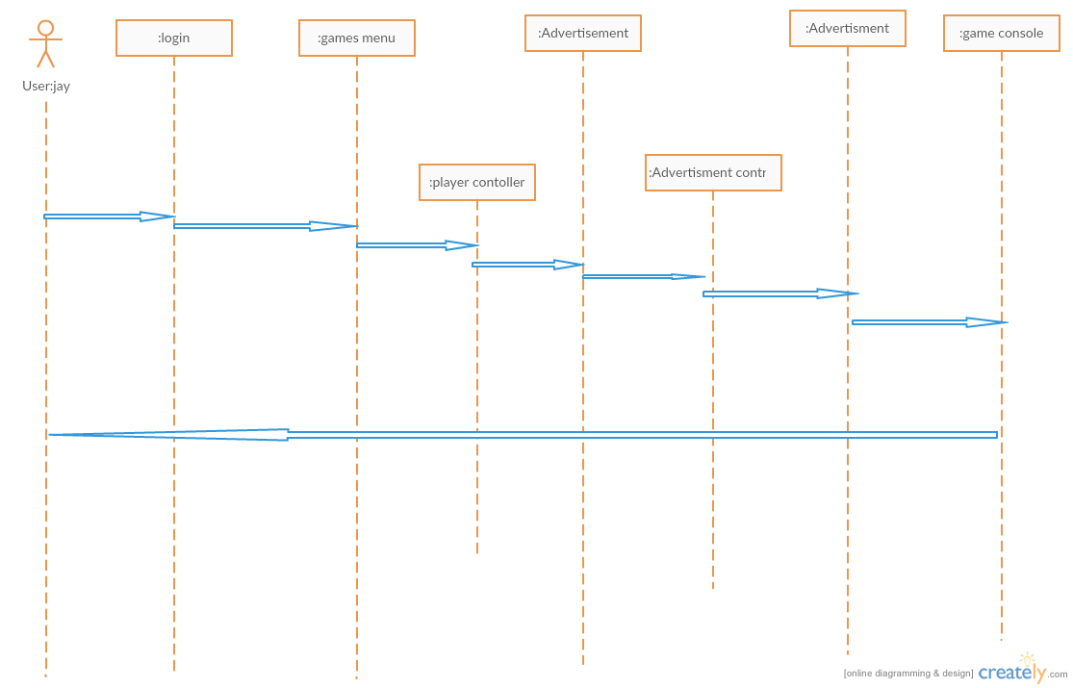

* In the above sequence diagram the user jay logins to his account and games menu and enters a game which player control object will display number of players on user interface if he clicks 2 players it will initiate advertisement control object which will display certain ad which was initiated by the user.

CLASS DIAGRAM:

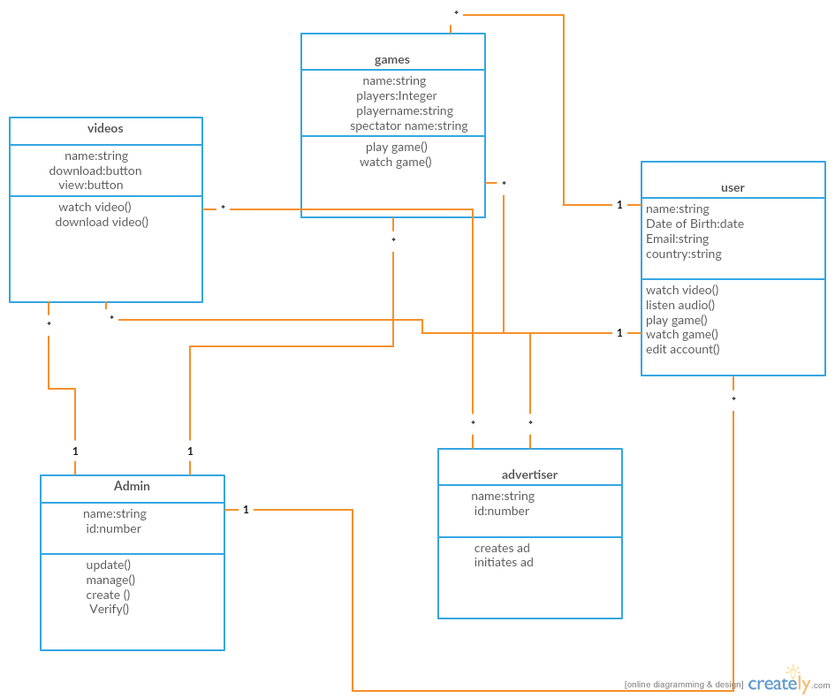

* In our class diagram consists of videos, games, admin and advertiser and user class.
* Videos which consists of operations watch video and download video.
* Games class can do operations of play game (), watchgame ().
* User can do operations like watch video and listen audio, edit account and watch game
* Admin can do operations like update, manage, create, verify accounts and update videos.
* Advertiser is responsible for displaying ads in front of the video.

SYSTEM DESIGN:

COMPONENT DIAGRAM:

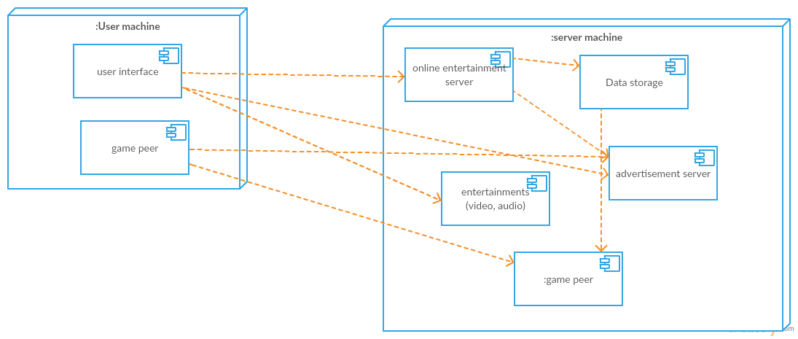

* In the above component diagram every single component has several subcomponents. In our project we consider client server architecture for entertainment purposes. And we used peer to peer connection for playing a game because a single game can be played as two players and in our application we are using a chat box for chatting when playing a game.

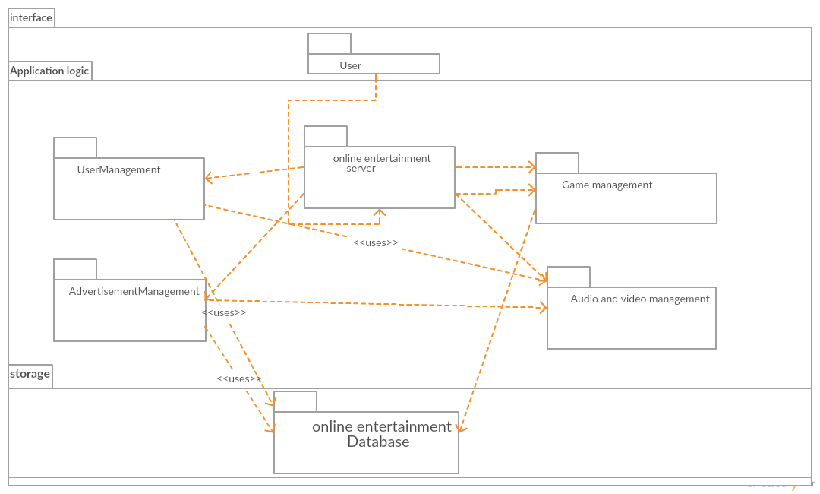

The above diagram is our online entertainment sub system decomposition where we divided in to interface and application logic and storage.